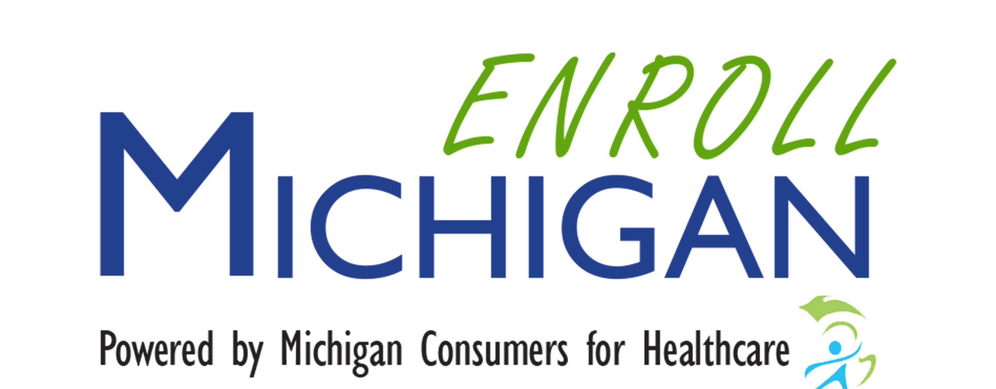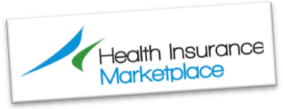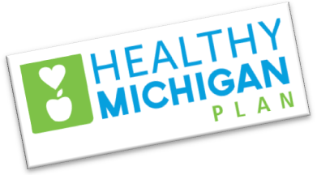

**NEED ASSISTANCE?**

Enrollment is easy. For assistance, go to Enroll Michigan to find a Navigator or assister: http://enrollmichigan.com/, or call

(517) 367-7293.

For any Medicaid programs, you may use the Enroll Michigan site to find an assister, your local Health Department, or your school-based health center:

**School-based health center information**

**Phone number**

You can also apply on-line yourself, using MI Bridges on-line application: https://www.mibridges.michigan.gov/access/. Either way, be sure to apply, and get your whole family covered!

Michigan has enrolled almost 1 million people in the past 2 years with Medicaid, and the Marketplace – don’t let your eligibility pass you by. Your school-based/linked health center can help you navigate these issues – please call us!

HEALTH CENTER LOGO HERE

**HEALTHY MICHIGAN PLAN**

The NEW Healthy Michigan Plan is available for adults, which expands Medicaid health coverage to many who previously were not eligible. Even if you have applied for Medicaid before, you can apply now, under the Healthy Michigan Plan, as there are different rules and requirements. You can apply any time for Medicaid, and Healthy Michigan Plan.

Families whose income is 133% or less of Federal Poverty Level (FPL), can enroll in the NEW Healthy Michigan Plan, Medicaid. (133%) of FPL for a family of one is **$16,243**, a family of 4 is **$33,465**, and family of 6 is **$44,947**.

For your children, please be sure they have coverage through Healthy Kids, or MiChild.

**HEALTH INSURANCE MARKETPLACE**

***Open enrollment begins again Nov. 1, 2015 – Jan. 31, 2016 for the Health Insurance Marketplace*** (healthcare.gov). Many who have enrolled are paying little or no premium, depending on their family size and income.

You do not want to miss this chance you have to check out the insurance plans available to you. You can find out how much the insurance costs, and are under no obligation to purchase coverage.

There are many affordable options available now to you and your family through the Healthy Michigan Plan, and the Health Insurance Marketplace.

**DO YOU NEED HEALTH INSURANCE FOR**

**YOU AND YOUR FAMILY?**