Find Local Help
Quick Reference Guide

Updating your organization’s information
Find Local Help has enhanced its features to provide our Assister organizations with greater access to managing their organization content. In order to update your information, you must use the upkeep tool at https://localhelp.healthcare.gov/update-organization-information/.

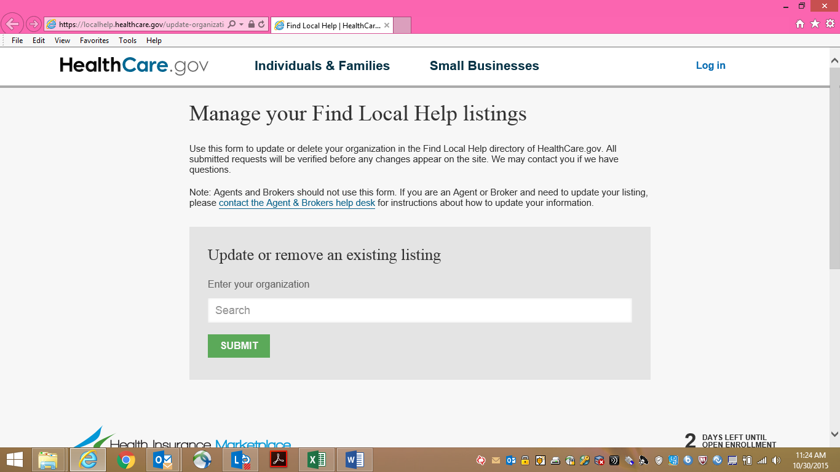

- Enter the organization name in the Search field.

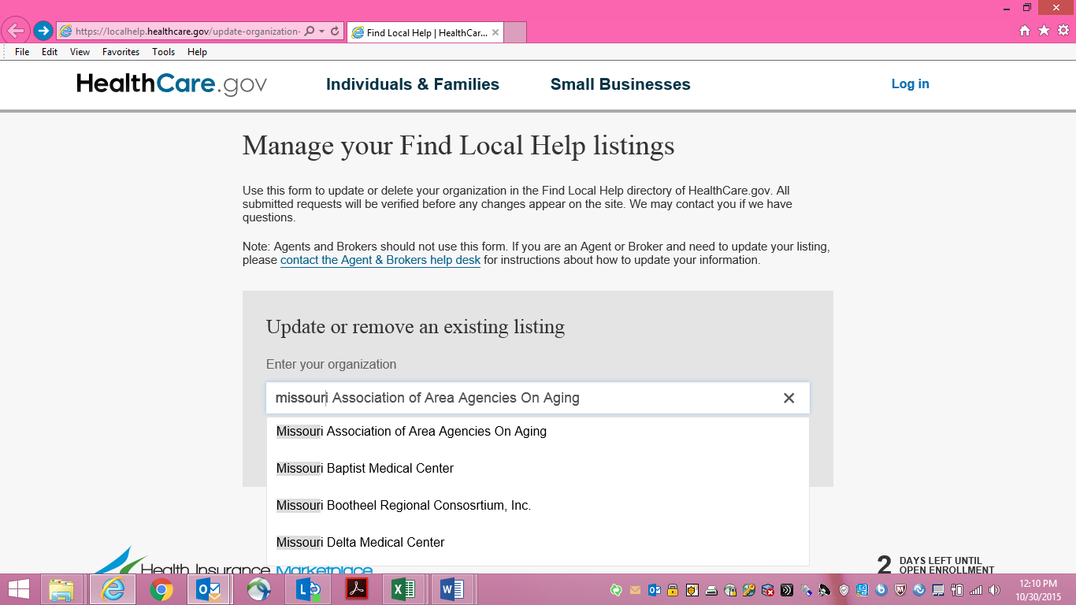

- Determine if you need to edit or delete an existing listing

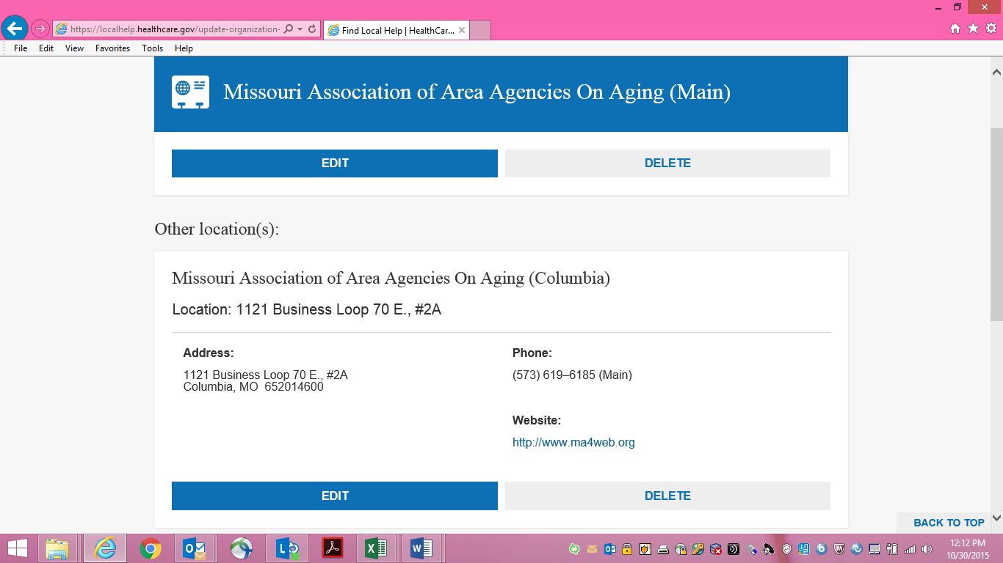

- You may edit the main record or a location. Once you select edit for either the main location or other location(s), you will need to update all request fields, including editing your address, reviewing contact information, and designating all operating hours per the screenshots:

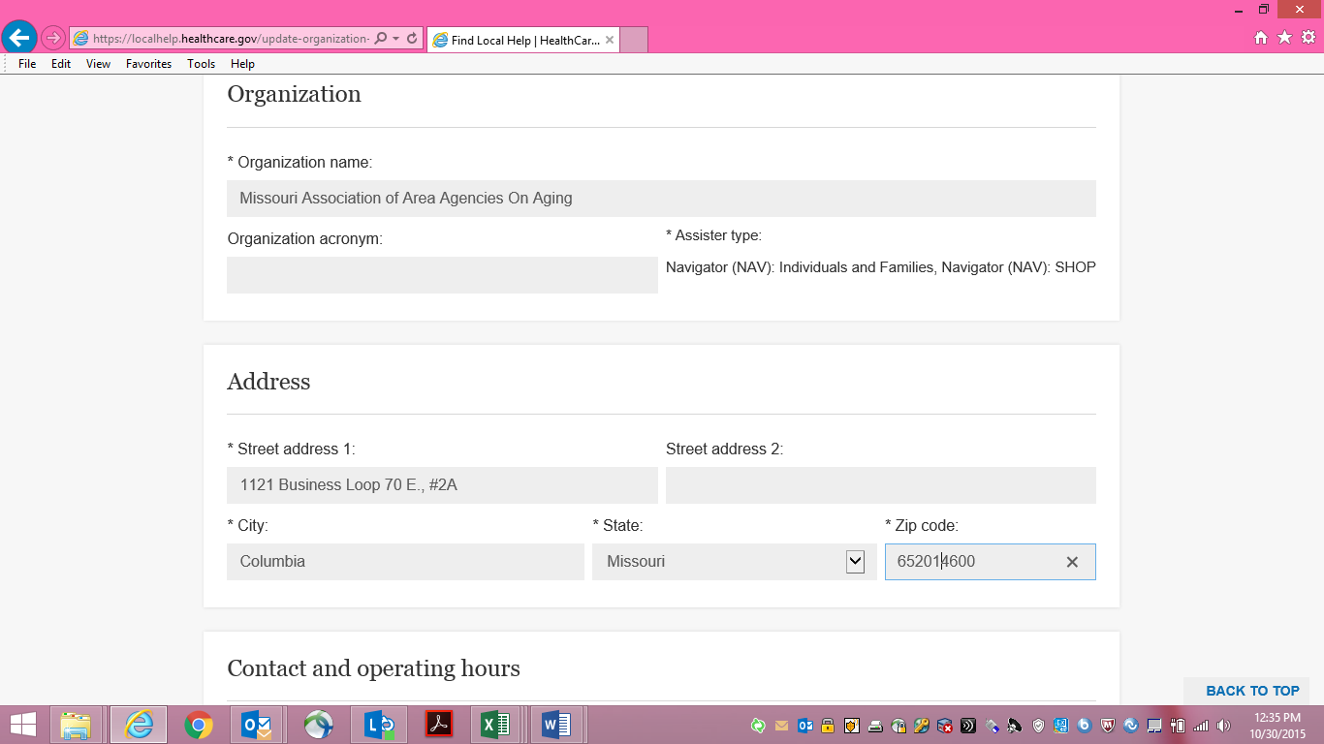

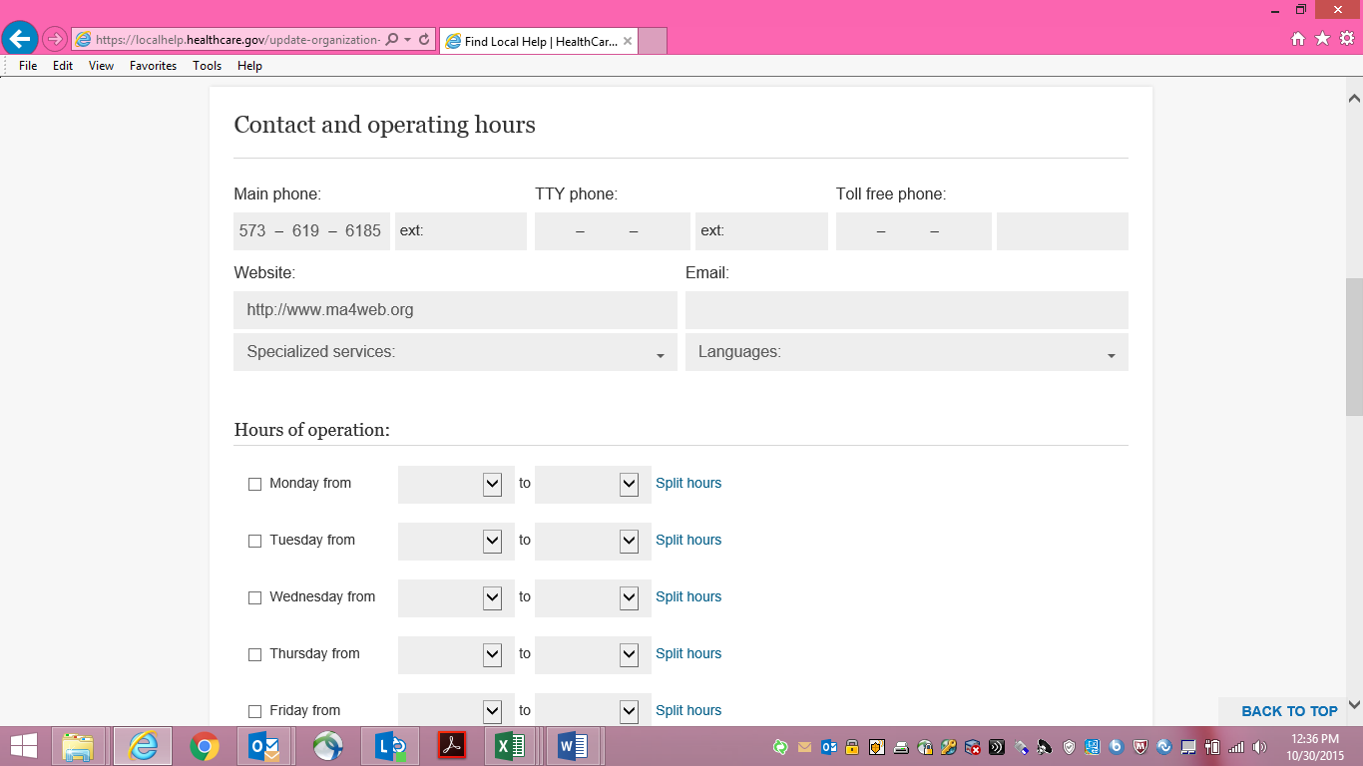

- The requester will need to submit their information in case we need to contact you. Pressing the continue button will initiate this request to update your information.

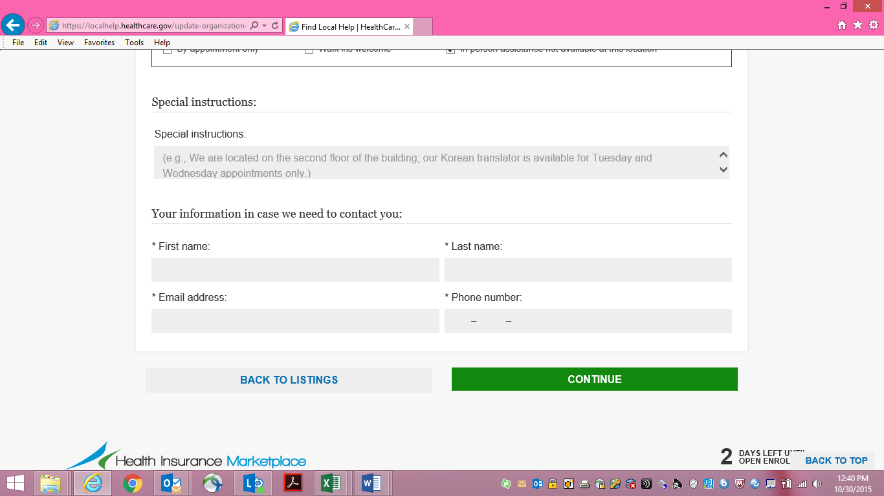

- You may also review your edits by selecting the edit button or you may continue by selecting the submit update request button:

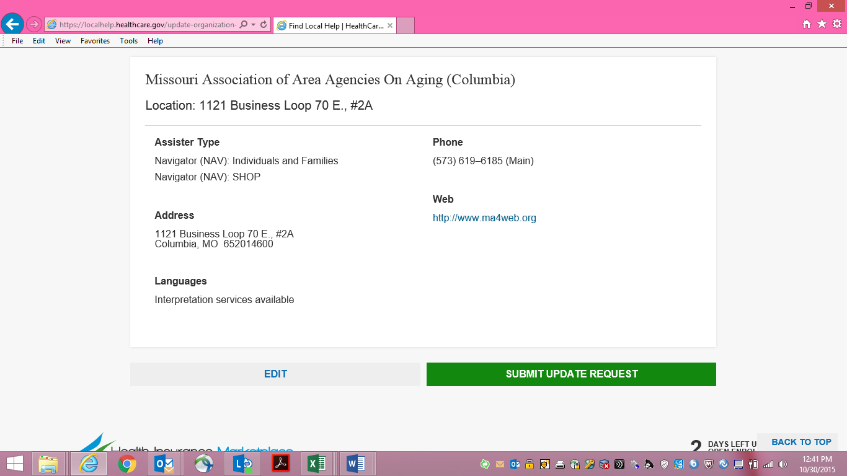

- After selecting the submit update request, you will receive notification that your request has been sent for review and approval.

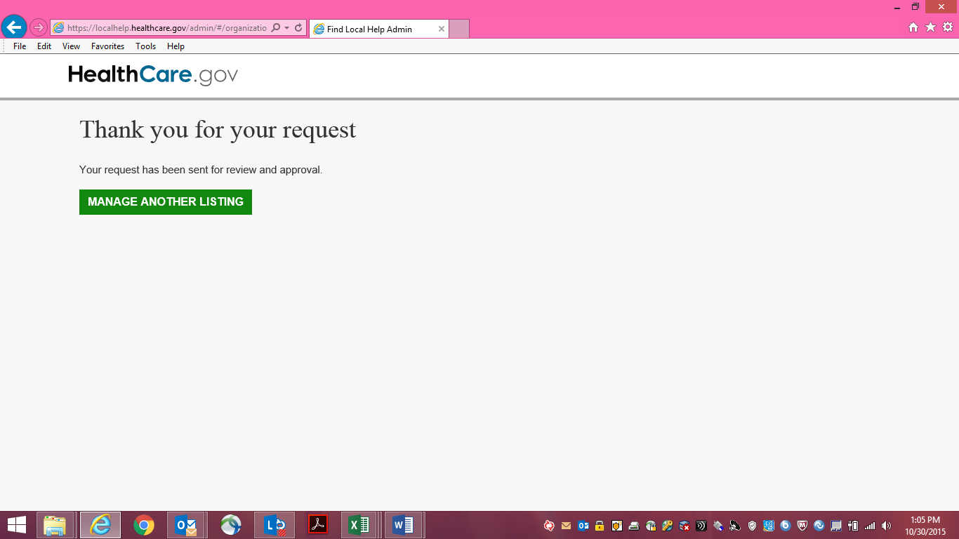

DELETING A RECORD
If you need to delete a record, please follow steps 1 and 2. You will then click on the delete button to request that the entry is deleted from Find Local Help. On the Verify Deletion of Find Local Help listing page, you will be requested to submit your contact information. (For testing purposes, fictitious contact information is included in the screenshot.)

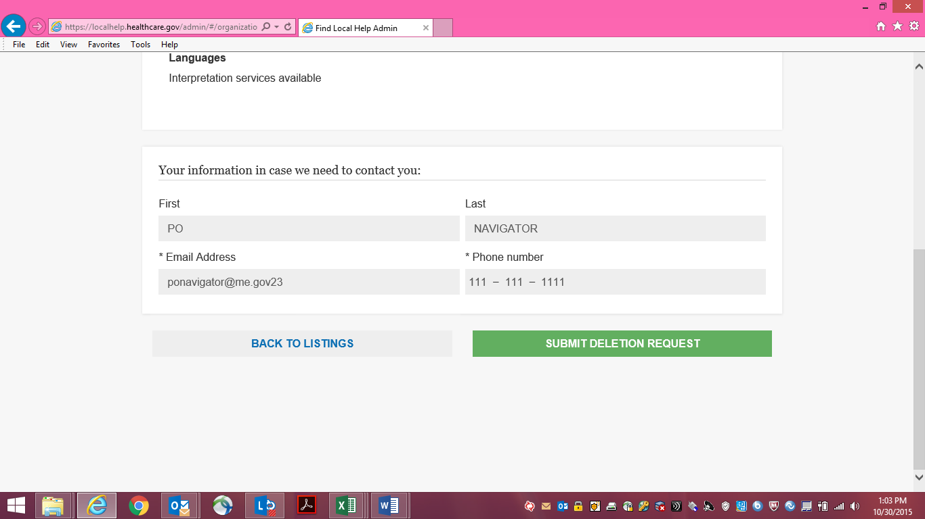

After selecting the submit deletion request button, you will be notified that your request has been sent for review and approval.

