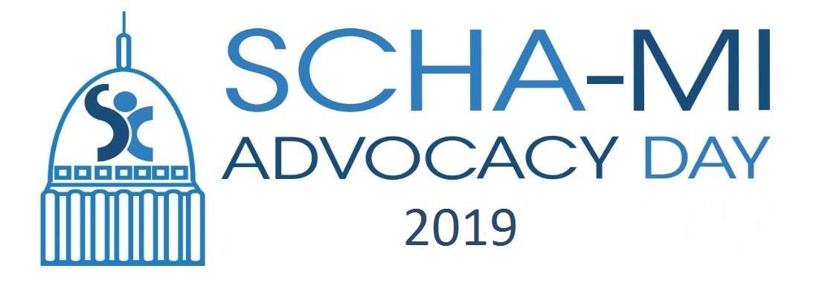

School-Community Health Alliance
Child and Adolescent Health Center
Advocacy Day Agenda
February 12, 2019

Registration and Networking 8:30-8:45
Welcome and Celebrating SBHC/CAHC Awareness Month 8:45-9:00
Tom Livezey, Board President, SCHA-MI

Legislative Visits and CAHC Legislative Policy Agenda 9:00-9:30
Renee Edmondson, Associate Director, SCHA-MI

Legislative Visits 9:30-11:45
Impacting the Lives of Children and Youth: Sharing Our Stories

Networking and Buffet Lunch Provided 11:45-12:00
Legislative Advocacy Award 12:00-12:15
Deb Brinson, Interim Executive Director, SCHA-MI
- Honorable Senator Peter MacGregor: Cherry Health
- Honorable Representative Aaron Miller: Cassopolis and Sturgis Health

Presentation: The Effectiveness of SBHC’s and Mental Health Services 12:15-12:40
Ty Partridge,PhD, Researcher Wayne State University

Introduction and Comments by K-12 Appropriation 12:40-1:00
Renee Edmondson, Associate Director, SCHA-MI
- Honorable Senator Wayne Schmidt: Chair, K-12 and Michigan Department of Education Senate Appropriations Subcommittee
- Honorable Representative Aaron Miller: Chair, School Aid and Department of Education House Appropriations Subcommittee

Legislative Visits 1:00-3:00
Impacting the Lives of Children and Youth: Sharing Our Stories

Adjourn 3:00
Thanks for the great day and work you do on behalf of MI Children!

Please use hashtag #SBHC19 for your pictures posted today, and send them to Kevin Lignell: klignell@scha-mi.org

