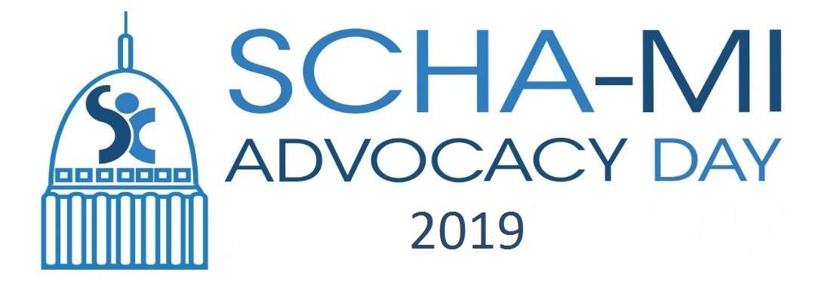

Miscellaneous Important Things

Happy School-Based Health Center Awareness Month!
What are you doing to celebrate? Post on our Facebook Page a picture and description of what you are doing to win one of 4 boxes full of hats and mittens/gloves for your center to distribute to needy kids.

SCHA-MI has a strong Twitter, and Facebook presence. Come be a part of it!

https://www.facebook.com/schoolcommunityhealthalliance/

twitter.com/SCHA_MI

Use our hashtag #SBHC19 on your posts today, and for Twitter, use #MISOTS19. This is a national movement, so try to promote them using these hashtags.

Any pictures today should be sent to our Kevin Lignell: klignell@scha-mi.org

Did you schedule a visit with your legislator? Please let us know where and when, and if you need any materials or other support!

New Award! The Guardian Angel Award, for Parent/Guardians on your Advisory Councils, who go over and above the call of duty! See attached form and description. Deadline to submit: Feb. 28, 2019

Upcoming Events: Youth Advocacy Day, May 15, 2019

