

**LOCATION & DIRECTIONS**

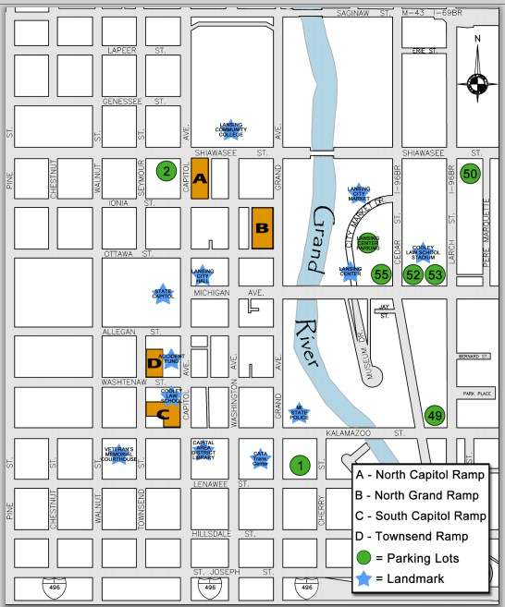

**HOB**

**SENATE**

[www.scha-mi.org](http://www.scha-mi.org/) | 517-908-0847 | 6035 Executive Drive, Suite 103 | Lansing, MI 48911