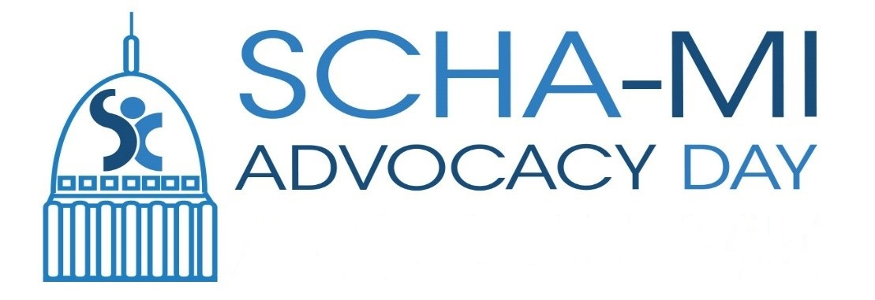

School-Community Health Alliance
Child and Adolescent Health Center
Advocacy Day Agenda
March 10, 2020

Registration and Networking 8:30-8:45
Welcome 8:45-9:00

Legislative Awards 9:00-9:30
Renee Edmondson, Associate Director, SCHA-MI
Legislative Awards

CAHC Legislative Policy Update
Legislative Visits 9:30-11:45

Networking and Buffet Lunch Provided 11:45-12:00
Legislative Award 12:00-12:15

Panel Presentation: Healthcare Changes and Financing 12:15-12:45

Legislative Visits 12:50-3:00

Adjourn 3:00
Thanks for the great day and work you do on behalf of children in Michigan!

Please use hashtag #SBHC20 for your pictures posted today, and send them to Marie Armstrong: marmstrong@scha-mi.org

